LogBook
By Vishnu Mahendrakumar
SID : 2261490

(Week 1)
Pros and cons of team work

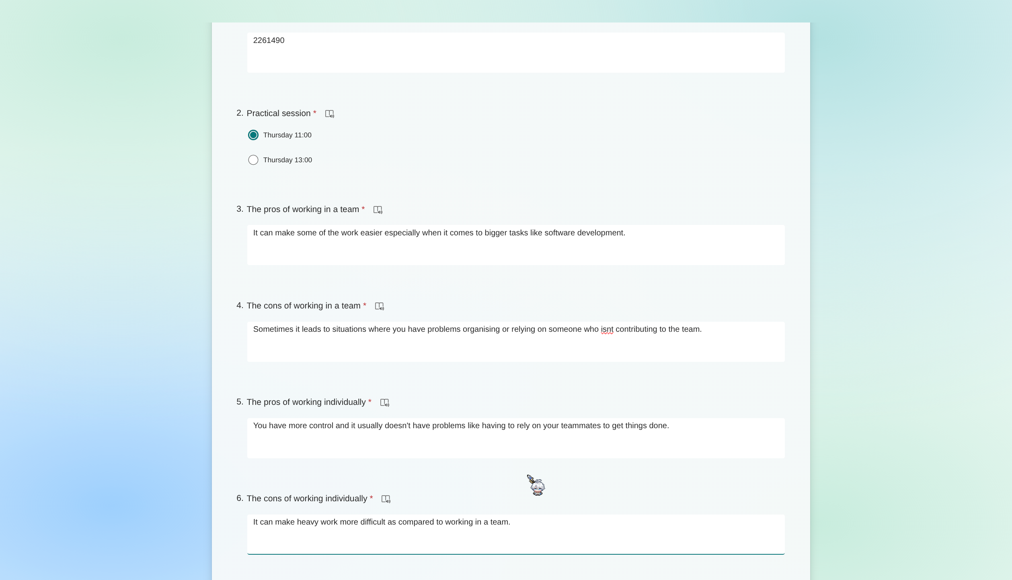

(Week 2)
We had a group meeting where we started discussing on the requirements for this project and started working on userstories and wireframes.
